THE ‘ACEQUIA DE AYNADAMAR’ AND LORCA’S DEATH

TEACHERS: Natalia Álvarez Fernándezand JUSTINA Castillo García

Lorca and his times
Subject _________________________
Title ___________________________
Year group 3rd Year ESO

Language Level ­­­­B1
Skills: Reading B1 /Writing B1 /Speaking B1 /Listening B1
Timing 3 LESSONS
Individual work YES / Pair work Yes/ Groupwork Yes
Goals
- You will learn about the watering systems during the muslim invasion
- You will learn about the Lorca’s Death
- You will know about mills in Acequia de Aynadamar.
- You will be able to use Google Slides
- You will be able to use Google Earth
- You will answer a questionnaire

THIS IS AN ACTIVITY INCLUDED IN THE INTEGRATED DIDACTIC UNIT ABOUT FEDERICO GARCÍA LORCA. IT IS A CONTRIBUTION TO ENGAGE STUDENTS IN THE LEARNING ABOUT LORCA’S DEATH FROM A DIFFERENT POINT OF VIEW, STUDYING AT THE SAME TIME THE NEARBY AREA.

AGE: 14
YEAR:: 3º ESO
SUBJECT: GEOGRAPHY

Engaging
We are going to follow the last steps of the poet. Those that tragically led to his death...in the Barranco de Viznar, just beside the irrigation canal that starts in this place. Do you want to discover it?
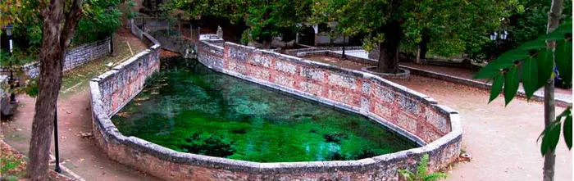

Explore
Federico García Lorca was taken in custody, sentenced to death and executed on 18th August 1936. You can watch this video or this other in english, to commemorate his sad end.

Explain
The place of Lorca’s death (article in English) is located somewhere in the road between Alfacar and Viznar. In this activity we are going to visit the places the poet could see on his terrible last trip, walking by the beautiful Acequia de Aynadamar (irrigation canal) that flows parallel to the road. The remains of the poet have never been found.

Practice
‘T Let’s start the walk by the Acequia de Aynadamar, and discover the most symbolic places and how it was used.
Click this link and travel with us or you can also use this QR code, if you want to do it with your mobile phone. This is an adventure in Google Earth.

Sharing
Now we want to bring Lorca’s poems to the place of his execution and read them there. You have to record one you previously have chosen in the literature lesson and upload it to this presentation together with your favourite pictures from the route.
Be careful and don’t download the presentation, just duplicate the slide template and write and put the information there.

Assessment
By finishing this trip you can find a questionnaire to assess what you have learnt about the Acequia de Aynadamar and Lorca’s death.

Extend your knowledge
You can extend your knowledge by using the following links.

http://legadonazari.blogspot.com/2015/07/acequia-de-aynadamar.html
https://www.elconfidencial.com/cultura/2018-06-05/federico-garcia-lorca-muerte-ultimos-dias_1574152/

Reflect on your learning and click….

CRITERIA | MY LEARNING
Listening
Speaking
Reading. I understand the text during the online trip
Writing. I am able to answer the

