MY FEDERICO GARCÍA LORCA’S NEW YORK INTERACTIVE MAP

TEACHER’S NOTES
Present the task to students
The goal is to create a “My Map” signalling Federico García Lorca’s landmarks in N.Y.
Students will deal with reading, listening, speaking and writing skills.
Steps:
- Give the students the short text about Federico García Lorca in N.Y. Let them read it individually. Comment on it.
- Play the video on how to create a map in Google Maps (teacher may have the map created before hand or may create it in front of the class to teach students how to do it)
- Explain the task: students will create texts to be added to the map signalling landmarks along with a photo.
- Hand out the cards with the information for the students to work in pairs (explain and show an example). Let the students work. Provide the students with a chart to fill in.
- Ask students to submit their work to classroom (and if possible, ask them to add their landmark to the editable map which link will also be in classroom)
- Show students the result of “My Map” and let them explore it!

MATERIALS:
1.- TEXT:
Federico García Lorca in New York.

That New York of 1929 was in black and White. It looked like everything was just about to happen, and everything seemed exciting. It was usual to get to N.Y. ocean liner with a visa for the U.S.A. and so did Federico García Lorca.
He arrived at night, he could see the lights in the skyscraper melting with the stars, there were lights everywhere. He was so shocked that he wrote back home to his parents explaining that Paris and London seemed little villages compared to New York. Granada’s population could fit in just three of these buildings, he said.
A few days after his arrival, Lorca was engaged in writing. From those first notes came “Poeta en Nueva York”
From Hudson river bank he headed to Columbia University Hall of Residence, in Broadway. From his window he could gaze the gardens. The university gave the students a map where Central park is just a rectangle and everything is geometrically ordered.
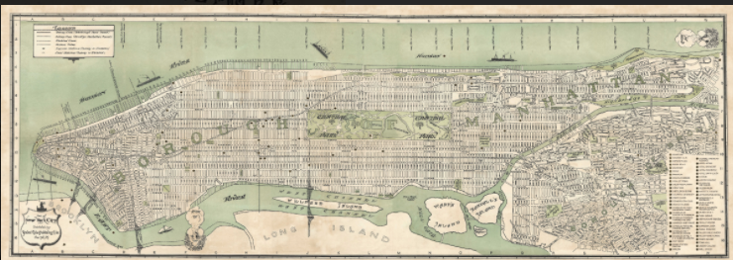
Everything starts with this map, Lorca would sign dozens of places. He walked a lot, more than he actually studied English. Sometimes he got lost on purpose, getting lost may result in finding yourself, he thought. He got lost in China town, he visited the shops and ate in a restaurant for 60 cents.
Let’s discover, place and explain the sites he visited and N.Y. landmarks related to Lorca!
Let’s create our own twenty-first century map!

2.- LINK: click on this link to learn how to create a map (your teacher will create one and share with you) https://www.youtube.com/watch?v=2aWKVqrbPVw
3.- CARDS:
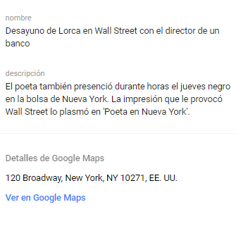 | 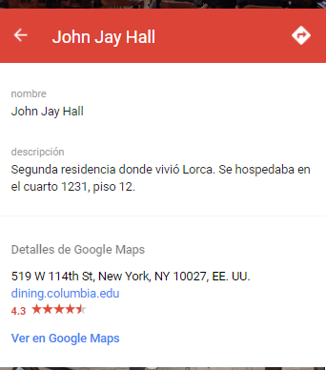
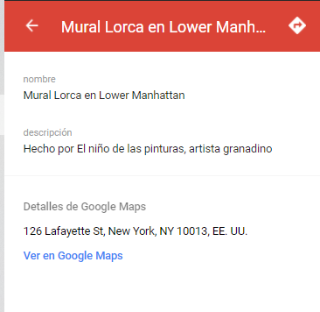 | 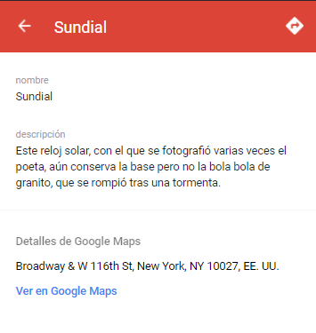
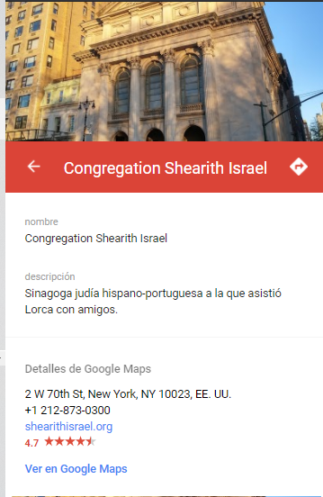 | 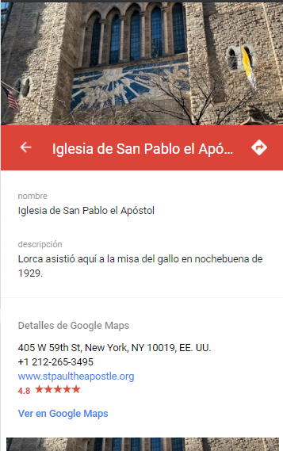
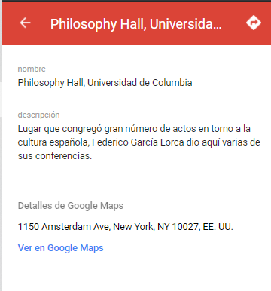 | 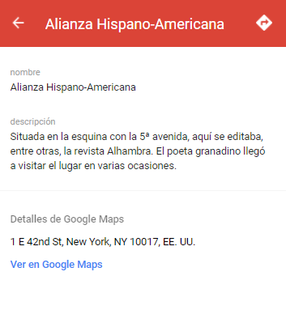
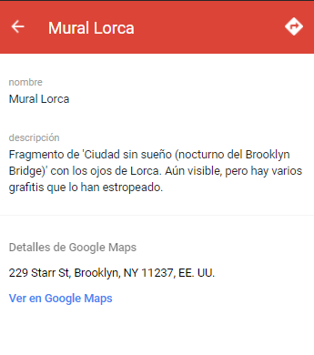

4.- CHART:
PHOTOGRAPH  TITLE  NAME  DESCRIPTION  ADRESS | Here is an example of how it should look like:

