Federico García Lorca biography
Student A

Federico García Lorca was a Spanish poet, playwright and prose writer. He .......... on June 5,1898 , in Fuente Vaqueros, province of Granada Spain, son of Federico García Rodríguez and Vicenta Lorca Romero, school teacher, who ........ him for the literary taste

The eldest of four brothers whose name of Baptism ......: Federico Del Sagrado Corazón De Jesús García Lorca. His early years were ...... in the rural environment of his Granada town and his greatest love of music, he ....... piano with Antonio Segura, at the University his friends....... him as a musician. He ..... the most influential and popular poet of the twentieth century Spanish literature and.......... to the Generation 27.

When he was eleven years old, the whole family ............ to Granada, where he ........his high school studies at the Sacred Heart high school. In 1909 he ........ to Granada with his family and ......... his university studies in Philosophy and Literature. He ......... in Law. In 1918 he ........ his first book in prose “Impresiones y Paisajes” and ........ some poems.
In 1919 he ....... to Madrid and ........ in the student residence where he .......until 1928, this place ......a lot of influence on his intellectual training since there he ........ characters such as John Maynard Keynes and Albert Einstein: Salvador Dalí, Luis Buñuel, Rafael Alberti, Juan Ramón Jiménez and Antonio Machado

Student B
In 1929, he .........to New York accepting the proposal of Fernando de Los Ríos, in order to learn English, change his life and renew his work. He ........ his stay in that city as one of the most useful in his life. In this city arises the book: “Poet in New York” which ...... ........ four years after his death.
In 1932 Federico García Lorca was ......the director of La Barraca, a university theater company that...... to bring the classical theater of the Golden Age to the towns of Castile.He ......... a high creative rhythm and ....... several works as: “Yerma,” “Doña Rosita la Soltera,” “La Casa de Bernarda Alba” and “Llanto by Ignacio Sánchez Mejías (published in 1935)
On July 14, 1936, he ......in Huerta de San Vicente, to join his family, then .......refuge in Granada, home of the family of his friend the poet Luis Rosales because he ...... safer there. But on the afternoon of August 16 of that same year, the Civil Guard ..... him, he ..... ....... to the Civil Government and then to the town of Víznar, spending his last night there (Due to his progressive ideas, his condition of homosexual and man of letters ..........him an object of persecution). The date of his death is still uncertain, it is said that Federico García Lorca .......... somewhere near the big fountain, next to the gully of Víznar (province of Granada) Spain, between August 17 and 19, 1936, at the age of 38, along with two banderilleros (Francisco Galadí and Joaquín Arcollas) and a school teacher (Dióscoro Galindo), all of republican ideology, his body is buried in an anonymous mass grave.

Reflect on your learning and click….
CRITERIA | MY LEARNING
Skills | 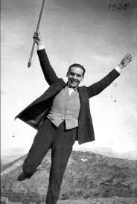 | 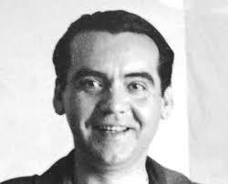 | 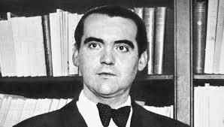
Listening
-I can understand information provided by my peer
Speaking
-I can pronounce ed of regular verbs fluently and know the irregular verb forms
Reading
I can read Lorca´s biography and infer the meanings of new .words from context
Writing
I can write down regular and irregular verb forms
Follow-up activity and goals for the future
Continue writing biographies as they help investigate into remarkable people and can fit into almost all curriculum areas: language arts, history, social studies, science, art, or computer studies.
Learning about the life story of a successful person can teach essential life skills, such as:
- persevere to achieve goals
- maintain a fair perspective and recognize other viewpoints
- listen to learn from others
- learn to be independent without relying on the opinion of peers
- take personal responsibility and accountability for your choices and actions
- develop a love of learning
- deal with failure
- be kind, helpful, and considerate of others

