A poem by Federico García Lorca
- Work in pairs and organize this poem by Federico García Lorca
https://es.educaplay.com/es/editarActividad.php?action=editarActividad&idActividad=8692572
- What do you think the title of the poem is?

- Read it again and illustrate it.

- Explain to your peers why you chose this illustration

Reflect on your learning and click….
CRITERIA | MY LEARNING
 |  | 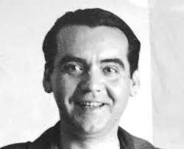 | 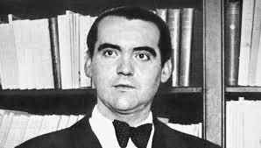
Speaking
I can share information with my peer and get to agreements to organise a poem
Reading
I can read and understand new vocabulary inferring from the context and illustrate it

Follow-up
Use the posters on the noticeboard to write a short poem about Federico Garcia Lorca

Poetry will continue to be a useful language tool in the future and Students will continue studying it because it helps them understand and appreciate the world around them. Besides, they can learn a great deal about a language by the ways speakers use its syllables and words into lines and stanzas.

